Special Projects Data Entry Instructions

- Go to the COVERLAB Special Projects page: https://coverlab.org/special-projects/.
- Watch the Training Video
- Click the button associated with the special project you are working to begin entering data for your route.
- Begin filling out your Troop information.
- Select your name from the Trooper Name list. You can type your name in the box to filter the list to your name quickly.
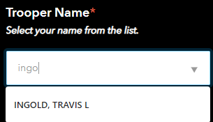
- Select the date you are working from the list of dates.
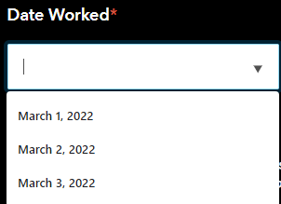

- Select the route you are working. You can only choose one route at a time and must submit a separate form for every additional route worked.
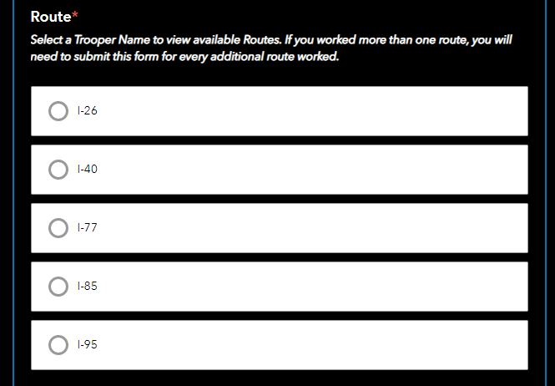

- Begin entering data as you normally would. Expand the groupings related to the data you are entering.
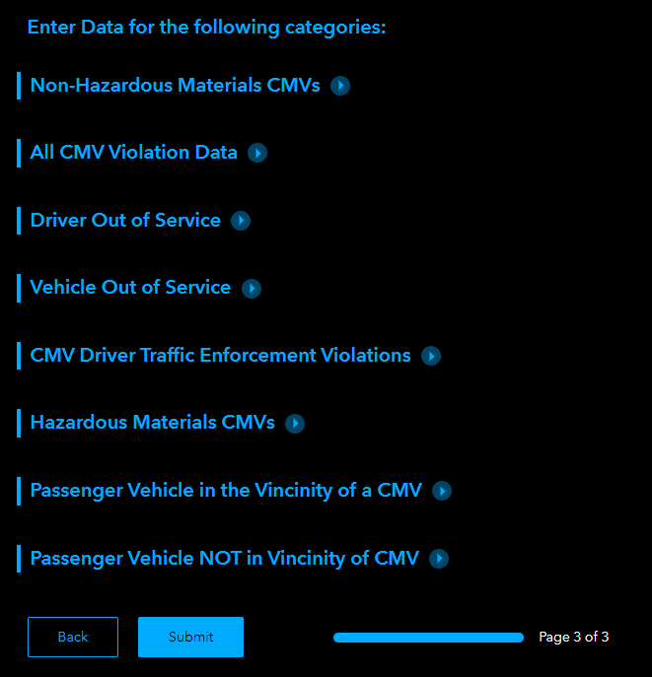

- Your answers are saved as you enter data. If you close and reopen this form, the data is not lost.
- When you are done working a route, submit the form.
- You will receive confirmation that your form has been submitted. You can enter data for another route if you worked multiple routes in one day.

