Data Entry Instructions for Drive/Traffic

Website and Resources
☐ Go to the special projects page on Coverlab: https://coverlab.org/special-projects/
☐ Optionally watch the data entry video at the bottom of the page.
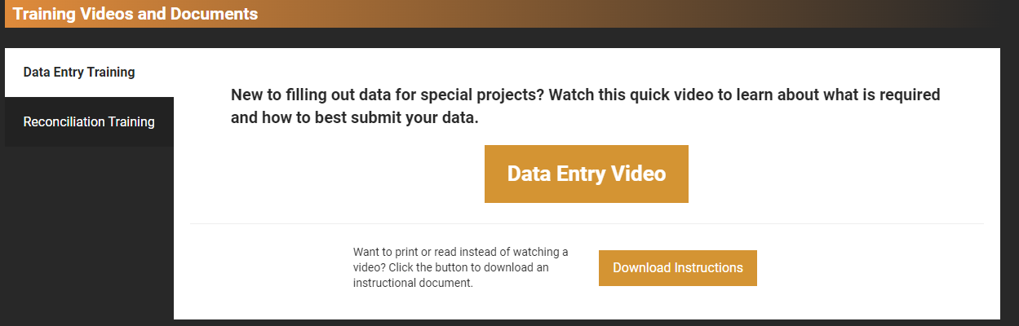
☐ Hover over the image of the special project you are working to access the Data Entry button. Then click Data Entry.
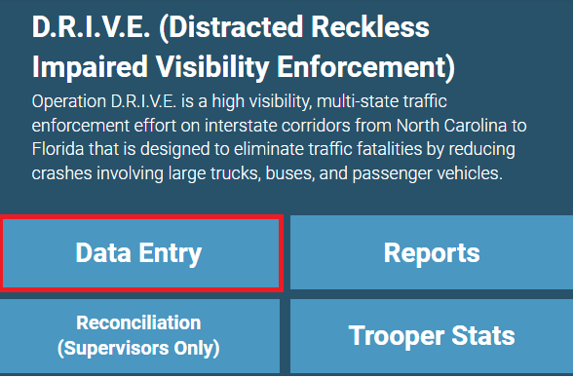

Data Entry Process
☐ Enter your name by typing in the box or selecting from the list. Registry number and troop will auto-calculate.
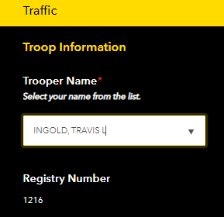
☐ Select the date and route worked. Note: If working multiple routes, you should submit the form again for any additional routes.
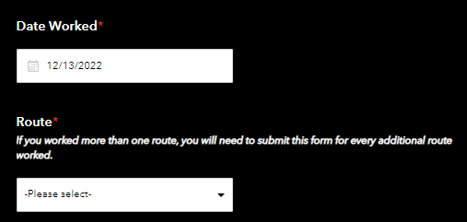
☐ Choose a category based on the data you need to enter. You can select ‘See all Categories’ if you want to see all the options. However, if you only need to enter data for a few things, you can select just those categories to cut down on the visual clutter to your screen.
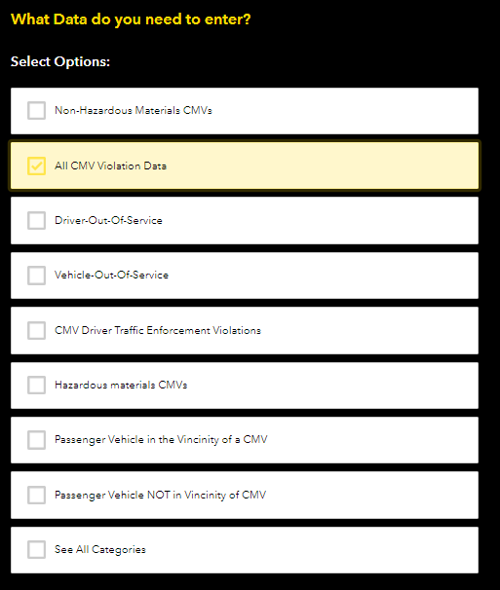
☐ On the next page, enter data and click ‘Submit’.
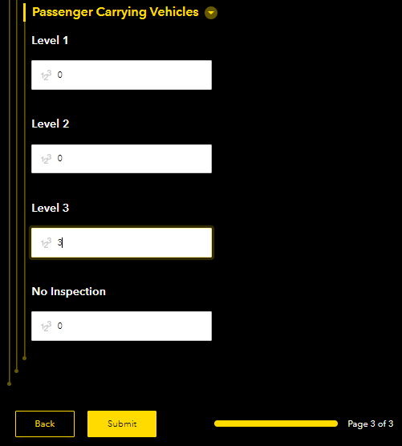

Help and Technical Issues
☐ For technical assistance, email help@coverlab.org or call 919-515-8587.

