Reconciliation Instructions for Drive/Traffic

Website and Resources
☐ Go to the special projects page on Coverlab: https://coverlab.org/special-projects/
☐ Optionally watch the reconciliation video at the bottom of the page.
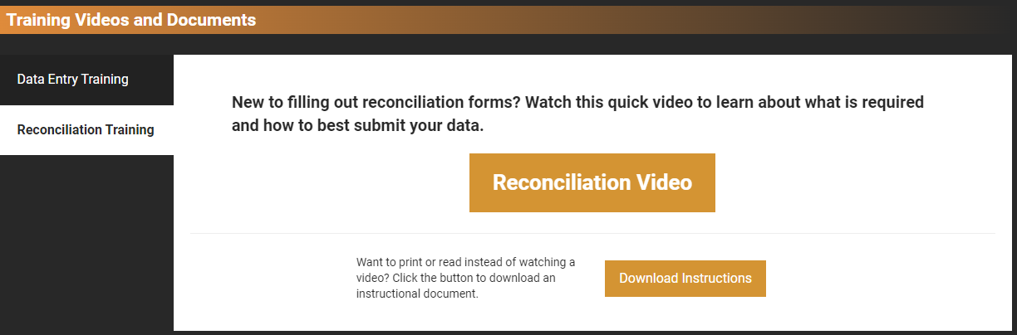
☐ Hover over the image of a special project to access the Reconciliation button. Then click Reconciliation.
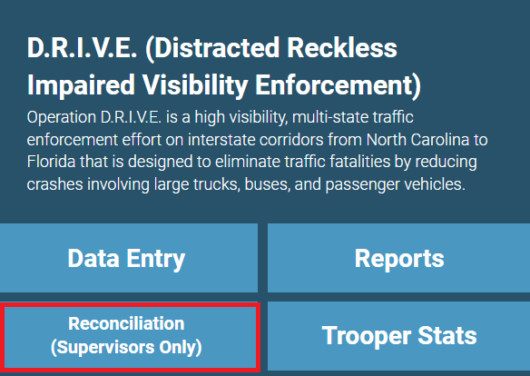
☐ You will be prompted for a username and password. The username is troopsupervisor and the password is Coverlab_SOPs2023.

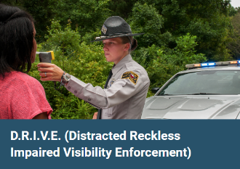
Reconciliation Process
☐ Select your Troop.
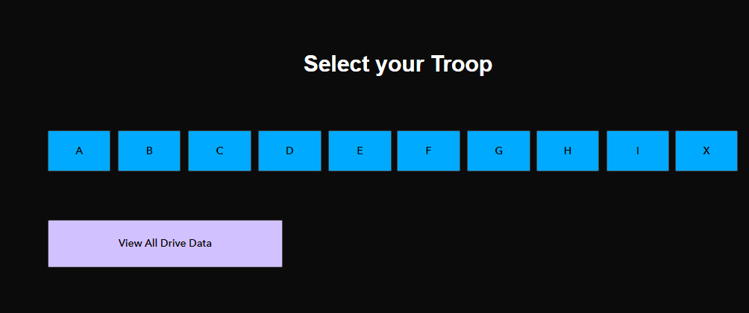
☐ Enter the name of the Trooper that is scheduled for an SOP shift. Troop should already be calculated.
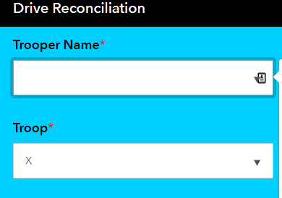
☐ Enter the District, Wave (if the project is Drive), Date Worked, and Hours Worked. Then click ‘Submit’. Note: If the project is Drive, Date worked will appear once the Wave is selected.
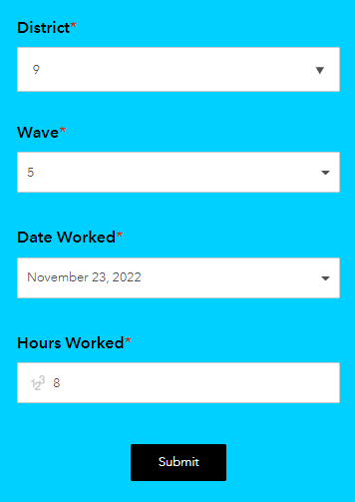
☐ To view the data in the table, click the arrows in the upper right corner to refresh the data.
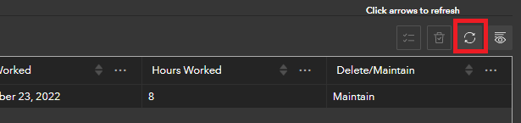
☐ To delete a row, double-click the ‘Maintain’ text and choose ‘Delete’ from the drop-down.

Help and Technical Issues
☐ For technical assistance, email help@coverlab.org or call 919-515-8587.

